For Immediate Release
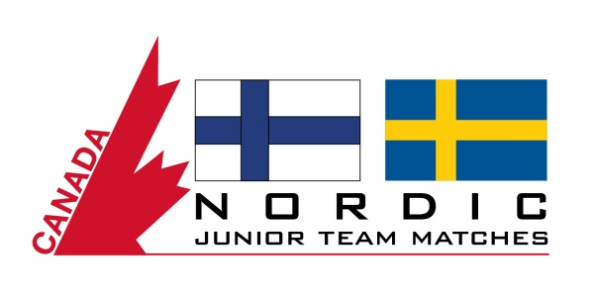

Maple Leaf Junior Golf Tour to send players to Nordic Team Matches in Finland

Vancouver, BC - (May 19, 2017) - The Boston Pizza-presented Maple Leaf Junior Golf Tour, Canada's number one-played junior golf tour, will be taking a team of young golfers overseas to compete in the inaugural Nordic Junior Team Matches in Helsinki, Finland, from August 27 to September 4, 2017.

With the support of MJT Official International Events Partner, TuGo, the Canadian team of four boys aged between 15 and 18 will play against Finland and Sweden in the first matches of this kind in this part of the world.

"This is an opportunity of a lifetime for MJT members, to meet the Head Coaches from Finland and Sweden and play against their top players at some great facilities,” said MJT National Operations Manager, Trent Matson, who will chaperone MJT Team Canada on this trip.

Qualifying to represent Canada in this event will be based on several MJT tournaments being held across the country, from which players will be short-listed from each province in relation to par, slope and rating before selecting the top four. To read more on the Nordic Junior Team Matches, please click here. To read more about MJT Official International Events Partner, TuGo, please visit www.tugo.com.

About TuGo: TuGo knows travel is a big part of any young, competitive sportsperson’s life and that travelling abroad helps junior golfers develop as players and as people. As Official International Events Partner, TuGo is pleased to partner with the Maple Leaf Junior Tour to support junior golfers and their families travelling to international events. For over 50 years, TuGo's dedication to travellers, partners and employees, has made it one of Canada's top travel insurance providers and a Canada's Best Managed Company. Together with their insurance partners, they’ve protected millions of people with travel insurance worldwide. They understand their customers' needs and are passionate about helping them have better experiences, providing top-rated claims assistance and customer service. www.tugo.com
About the MJT: The non-profit Maple Leaf Junior Golf Tour presented by Boston Pizza is Canada’s number one-played Junior Golf Tour as well as the only national junior tour run exclusively by PGA of Canada Professionals and the ‘Road to College Golf’ in Canada. The organization is presented nationally by Boston Pizza and supported by valued Premier, Tournament and Product Partners. The MJT hosts more than 70 events across Canada, including free Ford Go Golf Junior Clinics, the MJT Mini Tour for 7-12 year olds, the Collegiate Tour for 19-23 year olds, and multi-day events for competitive players aged 11 to 18 which are also qualifiers for international competitions. The program offers annual awards, scholarships, and frequent player incentives to help reward player's performance and participation throughout each season. MJT alumni include many Professional Tour players and PGA of Canada Professionals, as well as Canadian Amateur, National and Provincial Junior Champions. The MJT aims to develop champions, in golf and in life, promoting the game from grassroots through to provincial, national, university and professional level. For more information on the Maple Leaf Junior Golf Tour, please visit www.maplejt.com

MEDIA CONTACT: Elaine Denton, Director of Marketing & Administration, Maple Leaf Junior Golf Tour edenton@maplejt.com 1-877-859-GOLF www.maplejt.com.

Follow the MJT on Twitter, LIKE us on Facebook, Connect on LinkedIn, subscribe to MJT on Youtube or follow on Instagram

